TSAA – INGLÉS TÉCNICO II – 22 DE ABRIL

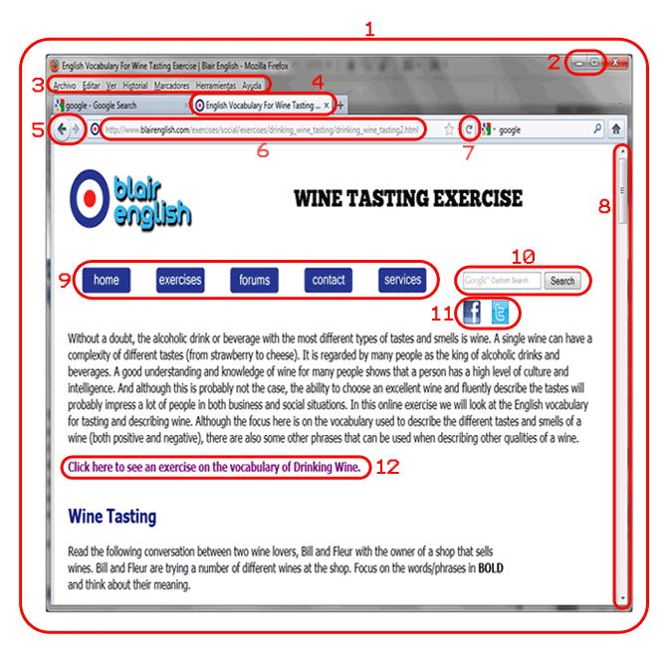

Write the numbers before the phrases.

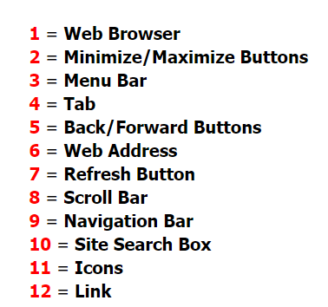





 

**quizz**

1. A part of the web browser where you can move up and down the web page, is the ____________

2. The buttons on a web browser which takes you to previous web pages that you have looked at, are __________________

3. A word or sentence on a web page that takes you to a different web page when 'clicked on' or 'pressed', is a _______________

4. A list of the different sections/parts of a website, is called a __________

5. The location or 'url' of a web page on the web, is called the__________

6. The place where you can quickly look for content on a website, is called the _______________

7. When you have multiple web pages open on a web browser, the name of each web page is written in a ________________

8. The two buttons that are used to make a web browser window disappear or make it cover the full screen, are called the __________

9. Small images on a web page, are called _____________

10. The name of the application used to view/see web pages on a computer, is called a _____________

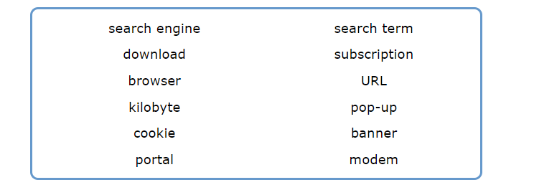 **Vocabulary II**